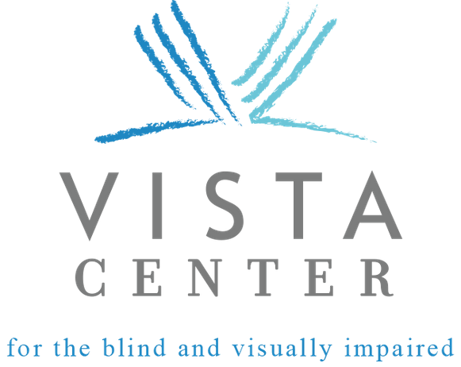

presents

September 28, 2019 | 9:00 AM - 4:00 PM

Venue Sponsor

Vista TEC 2019 Agenda

9:00 - 9:15 am Welcome (Redwoods Room)
9:15 – 10:00 am (Redwoods Room) Entertainment for all – Even Better Access! Hear about new products from technology companies that will enhance your entertainment enjoyment.

Moderator: Group Theory, Adrian Rodriguez Panelists: Amazon, Sarah Caplener - Audio Description Project (ADP), Susan Glass - Netflix, Spencer Hatch - Verizon Media, Gary Moulton

9:15 – 10:00 am (Coastside Room) Aira Breakout - Anirudh Koul

10:15 – 11:15 am (Redwoods Room) Autonomous Vehicles - When will I get into my own autonomous car? Where do autonomous vehicles stand today and when will they be ready?
Moderator: Ford, Dragos Maciuca
Panelists: Perceptive Automata, James Gowers - Lyft, Ezra Hayman - Ford, S. Joy Mountford

10:15 – 11:15 am (Coastside Room) HumanWare Breakout - Kevin Hughes

11:30 am – 12:15 pm (Redwoods Room) Artificial Intelligence - Will AI enable more inclusive experiences?
Come and enjoy a rich, fire-side conversation
with moderator Chris Yeh chatting with Andreas Forsland and Oscar Murillo.
Moderator: Chris Yeh
Panelists: Cognixion, Andreas Forsland and Microsoft, Oscar Murillo

11:30 am – 12:15 pm (Coastside Room) Project Invent - Designers of the Future Hear from local high school students who have designed two products for individuals with visual impairment.

Moderators: Project Invent, Connie Liu and Student Designer, Max Shen
Panelists: Student Designers, Deshaun Jordan, Maddie Park, and Wesley Shapiro and Team Participants, Abigayil Tamara and Jimmy Uharriet

12:15 pm – 1:00 pm Lunch (Redwoods Room) 1:00 – 1:30 pm (Coastside Room)
Group Theory, Adrian Rodriguez: A Blind
Engineer’s Mission to Make the Internet Universally Accessible

1:45 pm – 2:45 pm (Redwoods Room) Creating an Inclusive Workplace - How Tech
Companies are Bridging the Employment Gap
Leaders in technology will discuss how they encourage people with diverse abilities to thrive in an inclusive environment.

Moderator: Vista Center, Alice Turner Panelists: Amazon, Sarah Caplener - Walmart, Carrie Farber - HumanWare, Rachel Feinberg -
AIRA, Anirudh Koul - Adaptive Technology Services, Silvana Rainey

1:45 – 2:45 pm (Coastside Room)
Apple, Janette Barrios: Learn about Apple’s commitment to accessibility, and how we design with everyone in mind.
3:00 – 3:45 pm (Redwoods Room)
Artificial Intelligence - Can AI help people with Sensory/Physical disabilities?
Our panelists will discuss the capabilities of A-I for
creating a more diverse set of users.

Moderator: UCSC, Roberto Manduchi Panelists: Google, Patrick Clary - OrCam, Anat Nulman - Sunu, Marco Trujillo

3:45 - 4:00 pm Closing Remarks (Redwoods Room)

